VISHAL N

Data Scientists / Analyst

 +91 8015628822  [vishalmurugan006@gmail.com](mailto:vishalmurugan006@gmail.com)

# Profiessional summary

I am an aspiring data analyst and AI Enthusiast , currently pursuing my Btech-AI G DS. I have a deep interest in working with data analyzing patterns, extracting insights, and applying AI-driven solutions to real world problems. Beyond data science, I have a strong passion for game development. I enjoy combining creativity with technology using C,Unity and Blender to build engaging and immersive experiences. Exploring different aspects of software development has helped me develop problemsolving skills and a keen eye for detail.

I am also an active member of Toastmasters club where I continuously refine my communication and leadership skills. Driven by curiosity and innovation, I always seek opportunities to learn, improve, and push boundaries.

# Education

2023 - Now

## B-Tsch of Sťslla Mary's Collsgs of Enginssring, India, Nagsrcoil

Pursuing B.Tech in AI G Data Science at Stella Mary's College of Engineering. Gaining expertise in data analysis, machine learning, and AI-driven solutions, with a strong focus on real world applications and innovation.

2019 - 2023

**Highsr sscondary of SLB Govť. Highsr Sscondary School** Completed my higher secondary education as a biology student, building a strong understanding of scientific analysis and research. Later, I developed a passion for data science, seeing how data-driven insights can be applied to various fields, including healthcare and technology.

# Internships

# **Front-End(INBOX_Bootstrap)**

# **IBM(Data Analytics)**

# Projects

## SIH

Built S-Bin for Smart India Hackathon (SIH) — a sensor-based smart waste system, awarded seed funding for real-world development.

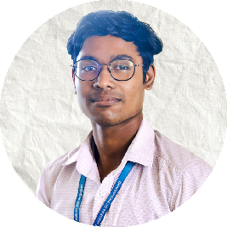

# Skills

Programming Skillful

Problem-Solving Experienced

Group Communication Experienced

# Links

 [Vishal-46](https://github.com/Vishal-46)  [Linkedin](http://www.linkedin.com/in/vishaln24)

# Languages

* English
* Tamil
* Japanese

# Hobbies

* 3D Modeling
* Reading Manga comics